# AMERICAN INTERNATIONAL UNIVERSITY BANGLADESH

Faculty of Engineering

# Laboratory Report Cover Sheet

***Students must complete all details except the faculty use part.***

Please submit all reports to your subject supervisor or the office of the concerned faculty.

Laboratory Title: **Familiarization with microcontrollers, study of blink test using and implementation of a traffic control system using microcontrollers.** Experiment Number: **01** Submission Date: ​​**27 September 2023**​ Semester: **Fall** Subject Code: **EEE 4103** Subject Name: ​​**Microprocessor and Embedded Systems**​  Section: **A** Course Instructor: ​​**PROTIK PARVEZ SHEIKH**​  Degree Program: **B.Sc. CSE**

## Declaration and Statement of Authorship:

1. I/we hold a copy of this report, which can be produced if the original is lost/ damaged.
2. This report is my/our original work and no part of it has been copied from any other student’s work or from any other source except where due acknowledgement is made.
3. No part of this report has been written for me/us by any other person except where such collaboration has been authorized by the lecturer/teacher concerned and is clearly acknowledged in the report.
4. I/we have not previously submitted or currently submitting this work for any other course/unit.
5. This work may be reproduced, communicated, compared and archived for the purpose of detecting plagiarism.
6. I/we give permission for a copy of my/our marked work to be retained by the school for review and comparison, including review by external examiners.

## I/we understand that

1. Plagiarism is the presentation of the work, idea or creation of another person as though it is your own. It is a form of cheating and is a very serious academic offence that may lead to expulsion from the University. Plagiarized material can be drawn from, and presented in, written, graphic and visual form, including electronic data, and oral presentations. Plagiarism occurs when the origin of the material used is not appropriately cited.
2. Enabling plagiarism is the act of assisting or allowing another person to plagiarize or to copy your work.

Group Number: **01** Individual Submission Group Submission

|  |  |  |  |  |
| --- | --- | --- | --- | --- |
| **No.** | **Student Name** | **Student ID** | **Signature** | **Contribution** |
| ***Submitted by:*** | | | | |
| **1** | **​ SATYAJIT DAS (CSE)** | **21-44374-1 ​** |  |  |
| ***Group Members:*** | | | | |
| **2** | **​​** **FATIN NOOR (CSE)** | **21-44729-1 ​** |  |  |
| **3** | **BORTOMAN DAS (CSE)** | **21-44429-1** |  |  |
| **4** | **ASHRAFUL HAQUE HIMEL (CSE)** | **​​19-40617-1 ​** |  |  |
| **5** | **​​​** |  |  |  |

|  |  |
| --- | --- |
| ***For faculty use only:*** | **Total Marks: Marks Obtained:** |
| **Faculty comments** | |

Table of Contents

Laboratory Report Cover Sheet 1

Title: 3

Objective: 3

Apparatus: 3

Lab Tasks: 3

Flowchart: 6

Result: 6

References: 6

Appendix: 6

# Title:

Familiarization with microcontrollers, study of blink test using and implementation of a traffic control system using microcontrollers.

# Objective:

This lab report's main goals are to thoroughly describe how to become familiar with microcontrollers and how to use them to create a traffic control system. This entails developing a fundamental knowledge of microcontroller architecture and programming, successfully completing the "Blink Test" to confirm microcontroller functionality, and then designing, constructing, and testing a useful traffic control system. The report seeks to describe the procedures followed, the materials used, and the programming languages used.

## Apparatus:

|  |  |
| --- | --- |
| Arduino IDE (any version) | Software |
| Arduino Uno (R3) board or Arduino mega 2560 board |  |
| LED lights (RED, GREEN and YELLOW) and three 200 ohms resisters and jumper wires. |  |

**Circuit Diagram:**

The Arduino platform is made up of the following components.

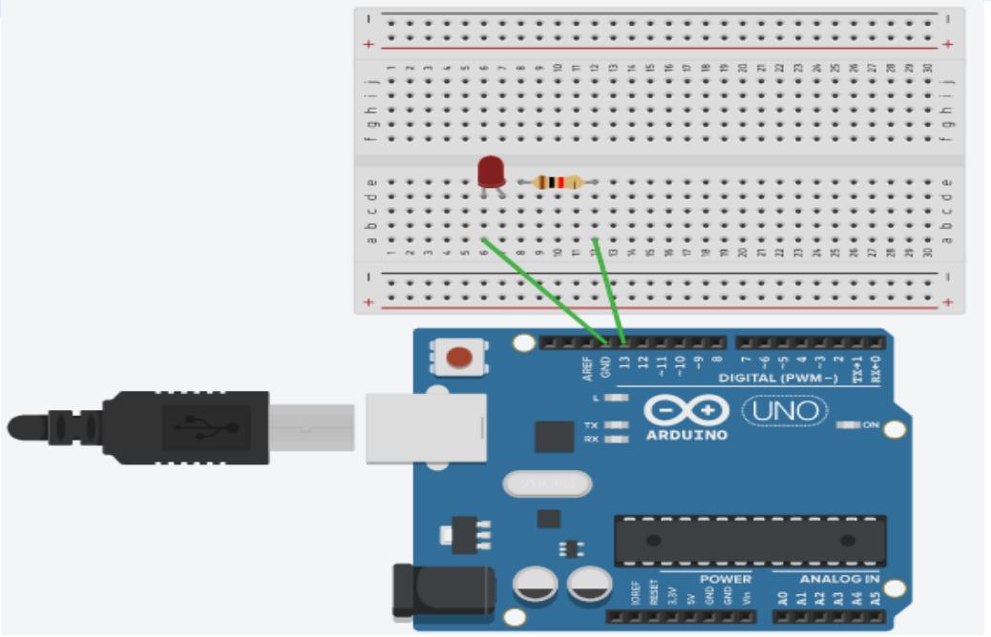

Figure Experimental Setup of Blink Test using an Arduino Microcontroller Board

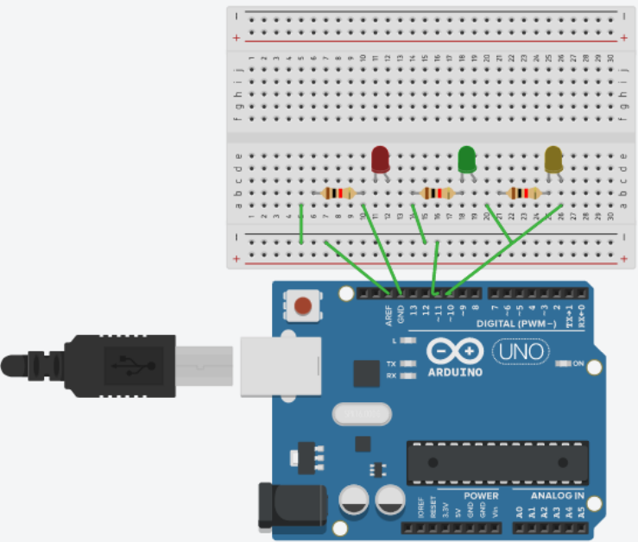

Figure Experimental Setup of a Traffic Control System using an Arduino Microcontroller Board

Code For Blink Test:

void setup() {

pinMode(8, OUTPUT);

}

void loop() {

digitalWrite(8, HIGH); // Turn the LED on

delay(1000); // Wait for 1 second

digitalWrite(8, LOW); // Turn the LED off

delay(1000); // Wait for 1 second

}

Code For Traffic Control system:

void setup() {

// pin connections for the LED lights

pinMode(8,OUTPUT);

pinMode(10,OUTPUT);

pinMode(12,OUTPUT);

}

void loop() {

// turning on voltage at output 8(for red LED)

digitalWrite(8,HIGH);

delay(3000); // red LED is on

// turning on voltage at output 8(for red LED)

digitalWrite(10,HIGH);

delay(1000); // yellow LED is on

//for turning off red and yellow and turning on green

digitalWrite(8,LOW);

digitalWrite(10,LOW);

digitalWrite(12,HIGH);

delay(3000);

digitalWrite(12,LOW); //green is off for blinking next

//to make green on and off for 3 times

delay(500);

digitalWrite(12,HIGH);

delay(500);

digitalWrite(12,LOW);

delay(500);

digitalWrite(12,HIGH);

delay(500);

digitalWrite(12,LOW);

delay(500);

digitalWrite(12,HIGH);

delay(500);

digitalWrite(12,LOW);

//to turn yellow on once

digitalWrite(10,HIGH);

delay(1000);

digitalWrite(10,LOW);

}

# Hardware Output Results: Here is the hardware implementation of the LED blink test and implement simple traffic control system test and the necessary explanation of the implementation:

# 

Figure 3 Hardware implementation for the blink test

# Explanation: In the following implementation, a jumper wire was connected at the pin 8 of the Arduino Uno board. The wire was then connected on the breadboard. The anode of an LED light was connected with the wire connected with pin 8. The cathode of the LED light was connected with a 100 Ω resistor. The following resistor was then connected with the Ground (GND) of the Arduino Uno board. The Arduino Uno board was connected with a PC to compile and import necessary codes. Here is the hardware implementation of Traffic Light System and the necessary explanation of the implementation:

# 

Figure Hardware circuit diagram for the traffic light system

# Explanation: In the following experiment, jumper wires were connected from pin 8, 10 and 12 of the Arduino Uno board to the anodes of the RED, YELLOW and GREEN LED consecutively. Three 100 Ω resistors were connected at each cathode of all the LEDs. Jumper wires were then connected at the negative common row of the breadboard. A jumper wire was connected then with the Ground (GND) of the Arduino Uno board from the common negative of the breadboard. The Arduino Uno board was connected with a PC to compile and import necessary codes.

# Experimental Output Results:

# Here are results of the light blink test:

# 

Figure LED is ON in Light Blink Test

# 

Figure LED is OFF in Light Blink Test

# 

# Here are results of the Traffic Light System:

# 

Figure RED LED is ON in Traffic Light System

# 

Figure Yellow LED is ON in Traffic Light System

# 

Figure Green LED is ON in Traffic Light System

# References:

1. <https://www.arduino.cc/>.
2. <https://www.coursera.org/learn/arduino/lecture/ei4ni/1-10-first-glance-at-a-program>
3. Jeremy Blue; Exploring Arduino: Tools and Techniques for Engineering Wizardry

**Appendix:**

For experimental video: (google drive link will be added here)